Git assignment

Ans – 1 - 6

1. Create a directory ‘project_dir’ & cd to ‘project_dir’.

2. Initialize git version database. (git init)

3. Create a new file index.html.

4. Check the git status. You should find index.html as untracked file.

5. Stage the index.html file.

6. Commit index.html

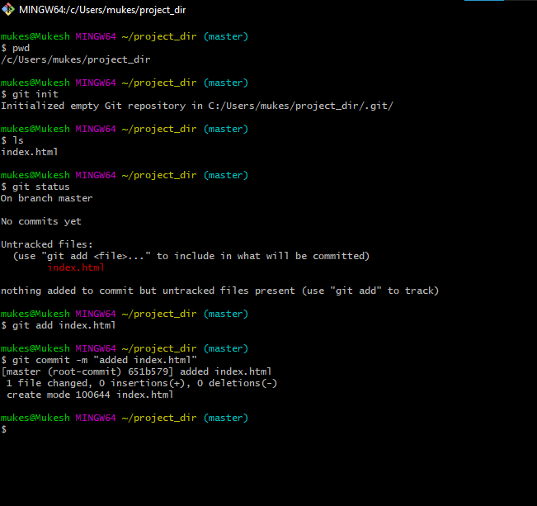

Ans – 7 – 11

7. Make few changes in index.html & create a new file info.txt file.

8. Check git status. You should find index.html & info.txt as untracked files.

9. Configure GIT to ignore all txt files.

10. Again check the git status. You should find only index.html as untracked file.

11. State & commit index.html

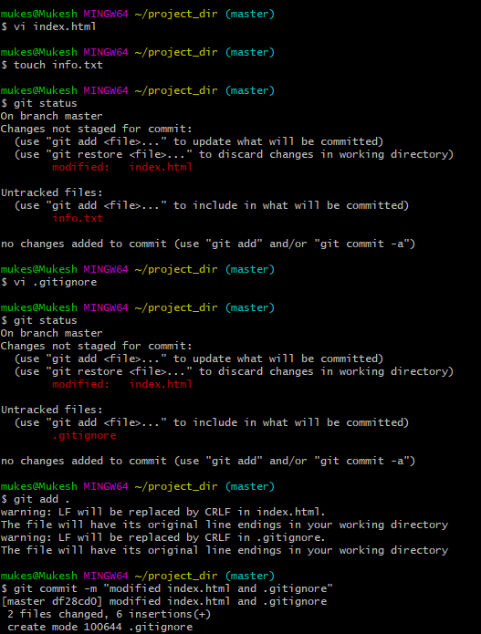

Ans – 12 – 14

12. Log all your comments so far.

13. Make some changes in index.html.

14. Revert the change made in the previous step using git command.

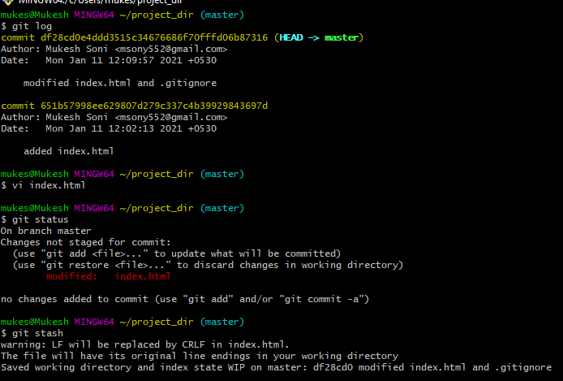

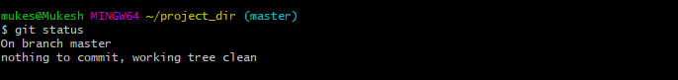

Ans – 15 – 17

15. Again change index.html.

16. Stage index.html

17. Revert back the last stage.

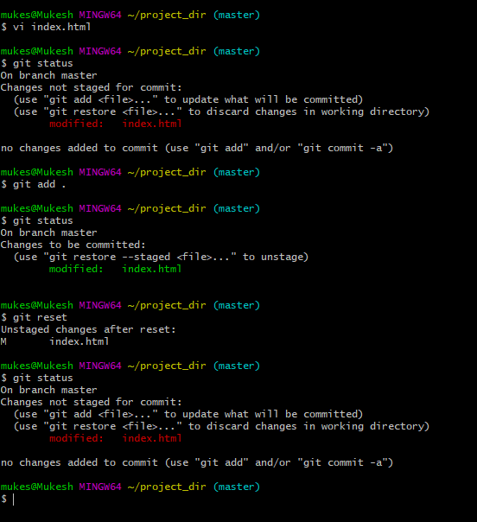

Ans – 18 – 20

18. Rename ‘add’ command to ‘my-add’.

19. Using my_add command Stage index.html again & commit the changes.

20. Revert the last commit.

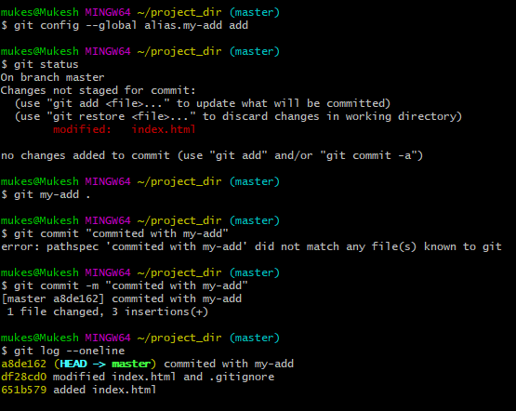 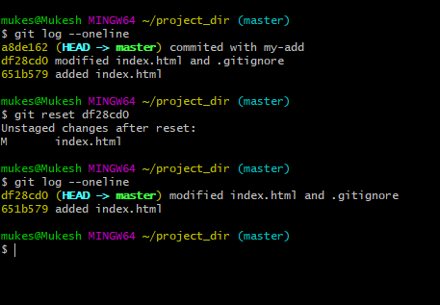

SECTION-1 (HTML assignments) - Steps to follow:

Ans – 21 – 24

21. First take a backup of your assignments & projects. This is required because due to incorrect GIT operation you may lose your files.

22. Create an empty directory ‘Assignments’ & cd to ‘Assignments’.

23. Create a file README.txt inside ‘Assignments’ & write few lines about the contents of ‘Assignments’ folder.

24. Commit README.txt file

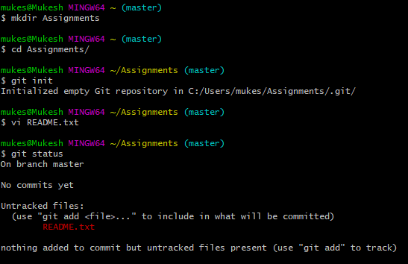

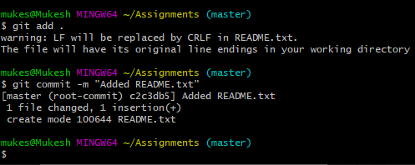

Ans – 25 – 30

25. Now create a new branch ‘html-assignments’.

26. Switch to ‘html-assignments’ branch.

27. Copy all HTML assignments inside ‘Assignments’ folder.

28. Commit HTML assignments into ‘html-assignments’ branch.

29. Make minor changes into few files belonging to ‘html-assignments’ branch.

30. Commit those changed files.

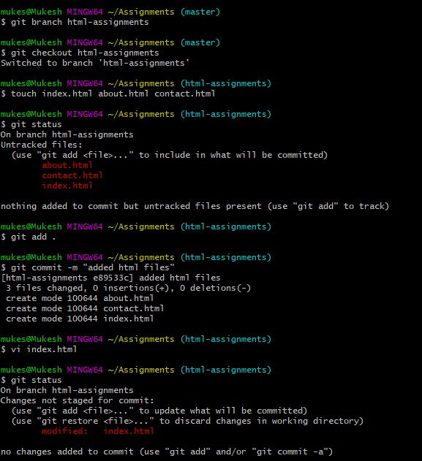 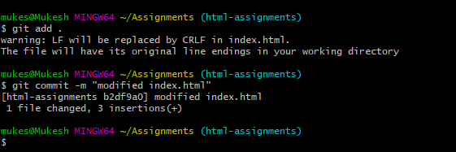

Ans – 31 – 35

31. Switch to master branch.

32. Make minor changes into README.txt file & commit those changes into master.

33. Again switch to ‘html-assignments’ branch.

34. Make minor changes into few files belonging to ‘html-assignments’ branch.

35. Commit those changes

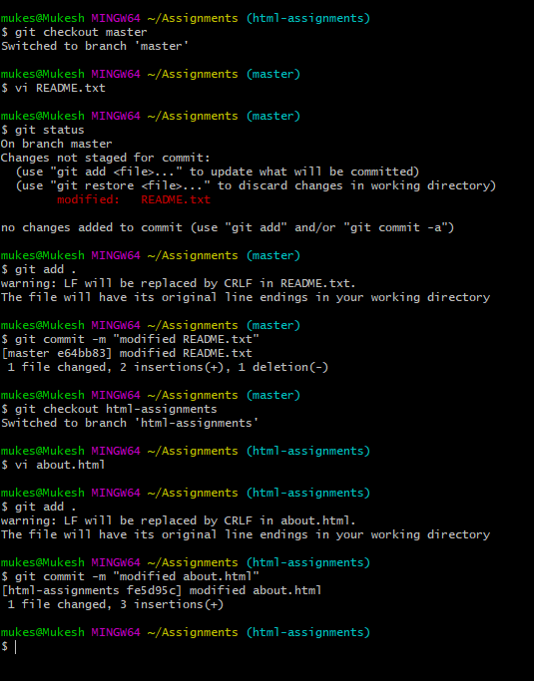

Ans – 36 – 38

36. Switch to master.

37. Merge ‘html-assignments’ branch into master. Confirm all html assignments are shown in master.

38. Finally delete the ‘html-assignments’ branch

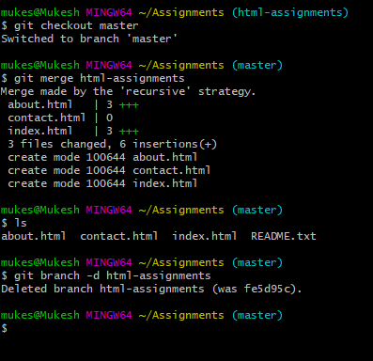

SECTION-2 - (CSS assignments) Steps to follow:

1. Create a new branch ‘css-assignments’.

2. Switch to ‘css-assignments’ branch.

3. Copy all CSS assignments inside ‘Assignments’ folder.

4. Commit CSS assignments into ‘css-assignments’ branch.

5. Make minor changes into README.txt file on line 1 belonging to ‘css-assignments’ branch.

6. Commit those changed files.

7. Switch to master branch

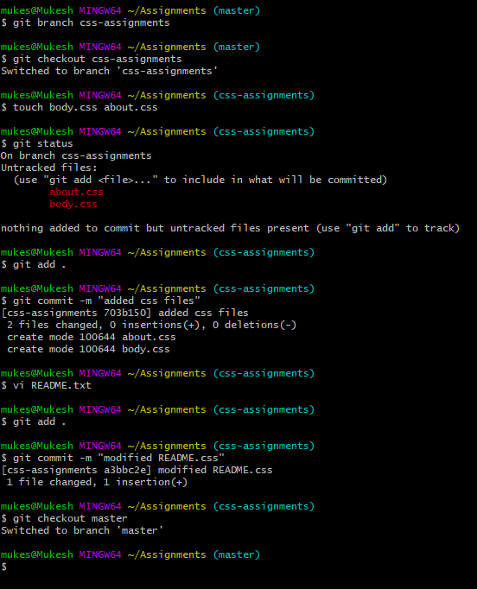

Ans – 8 – 11

8. Make minor changes into README.txt file on line 3 & commit those changes into master.

9. Again switch to ‘css-assignments’ branch.

10. Make minor changes into few files belonging to ‘css-assignments’ branch.

11. Commit those changes.

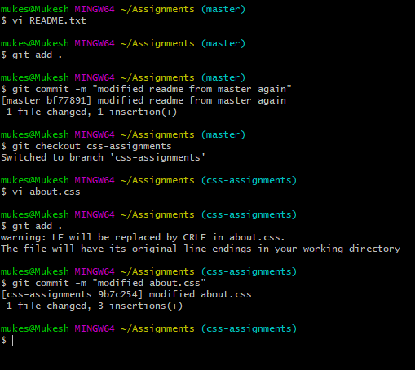

Ans – 12 – 14

12. Switch to master.

13. Merge ‘css-assignments’ branch into master. Confirm all css assignments are shown in master.

14. Finally delete the ‘css-assignments’ branch.

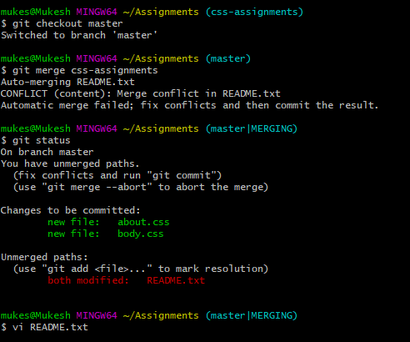 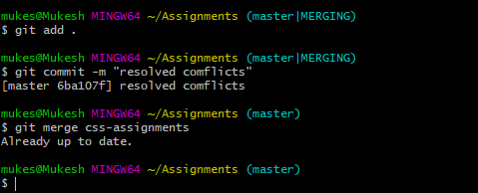 

SECTION-3 - (JavaScript assignments) Steps to follow:

1. Create a new branch ‘js-assignments’.

2. Switch to ‘js-assignments’ branch.

3. Copy all JavaScript assignments inside ‘Assignments’ folder.

4. Commit JavaScript assignments into ‘js-assignments’ branch.

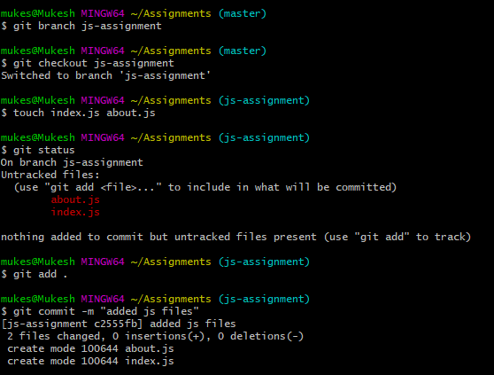

5. Make minor changes into README.txt file on line 1 belonging to ‘js-assignments’ branch.

6. Commit those changed files.

7. Switch to master branch.

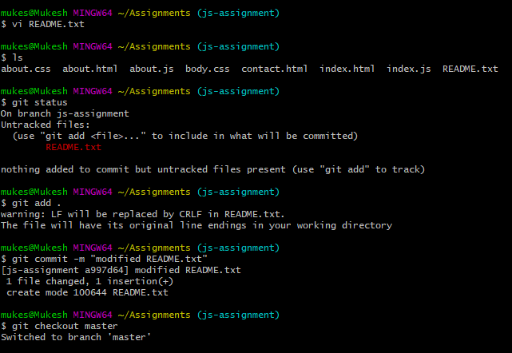

Ans – 8 – 12

8. Make minor changes into README.txt file on line 1 & commit those changes into master.

9. Again switch to ‘js-assignments’ branch.

10. Make minor changes into few files belonging to ‘js-assignments’ branch.

11. Commit those changes.

12. Switch to master

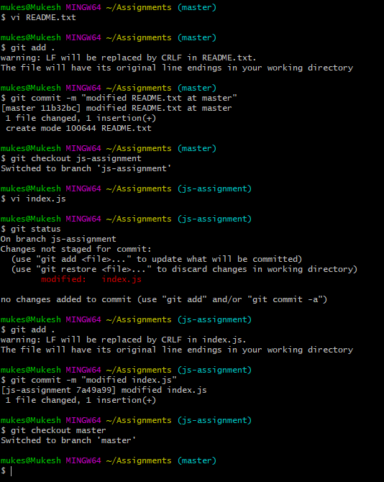

Ans – 13 – 14

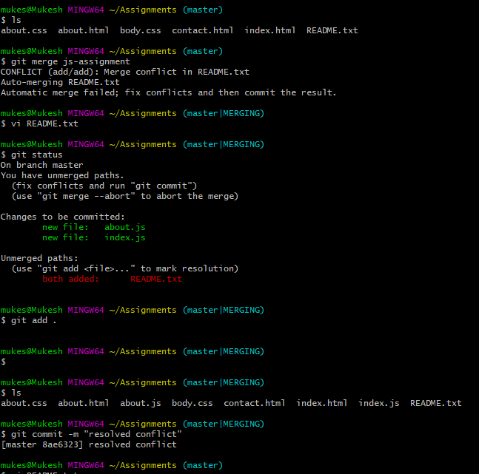

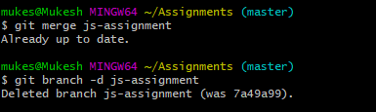

SECTION-1 (Pushing assignments to remote repository) - Steps to follow:

39. Create a GitHub account if you do not have already.

40. Login on into GitHub account.

41. Create new public repository ‘freshersbatch-oct16’.

42. Commit & push any sample file to this repository under ‘Assignments’ directory.

Ans - <https://github.com/imukeshsoni/Assignments>